ATLIQ HARDWARES SALES ANALYSIS  
  
Ad-Hoc Requests

**1. Provide the list of markets in which customer "AtliQ Exclusive" operates its business in the APAC region.  
  
Input Code:  
SELECT DISTINCT market FROM dim_customer**

**WHERE customer = 'Atliq Exclusive' AND region = 'APAC';  
  
Output:**

**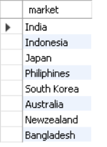  
  
  
2. What is the percentage of unique product increase in 2021 vs. 2020?**

**Input Code:  
SELECT X.A AS unique_product_2020, Y.B AS unique_products_2021, ROUND((B-A)*100/A, 2) AS percentage_chg**

**FROM**

**(**

**(SELECT COUNT(DISTINCT(product_code)) AS A FROM fact_sales_monthly**

**WHERE fiscal_year = 2020) X,**

**(SELECT COUNT(DISTINCT(product_code)) AS B FROM fact_sales_monthly**

**WHERE fiscal_year = 2021) Y**

**);  
  
Output:  
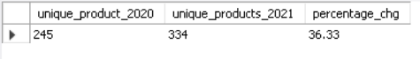**

**3. Provide a report with all the unique product counts for each segment and sort them in descending order of product counts.**

**Input Code:  
SELECT segment, count(DISTINCT product_code) AS product_count FROM dim_product**

**GROUP BY segment**

**ORDER BY product_count DESC;  
  
Output:  
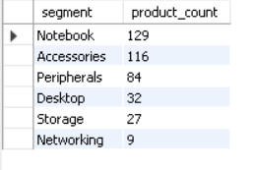**

**4. Follow-up: Which segment had the most increase in unique products in 2021 vs 2020?   
  
Input Code:  
WITH cte AS**

**(**

**SELECT**

**a.segment AS segment,**

**COUNT(distinct**

**(CASE WHEN fiscal_year = '2020' THEN a.product_code END)) AS product_count_2020,**

**COUNT(DISTINCT**

**(CASE WHEN fiscal_year = '2021' THEN a.product_code END)) AS product_count_2021**

**FROM dim_product AS a**

**JOIN fact_sales_monthly AS b**

**ON a.product_code = b.product_code**

**GROUP BY a.segment**

**)**

**SELECT segment, product_count_2020, product_count_2021, (product_count_2021 - product_count_2020) AS product_count_difference**

**FROM cte**

**ORDER BY product_count_difference DESC;  
  
Output:  
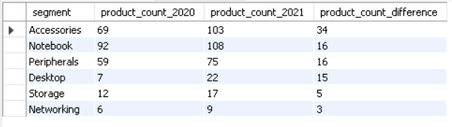**

**5. Get the products that have the highest and lowest manufacturing costs.   
  
Input Code:  
SELECT dp.product_code, dp.product, manufacturing_cost**

**FROM dim_product AS dp**

**JOIN fact_manufacturing_cost AS mc**

**ON dp.product_code = mc.product_code**

**WHERE manufacturing_cost = ( SELECT MAX(manufacturing_cost) AS manufacturing_cost FROM fact_manufacturing_cost) OR**

**manufacturing_cost = ( SELECT MIN(manufacturing_cost) AS manufacturing_cost FROM fact_manufacturing_cost)**

**ORDER BY manufacturing_cost DESC;  
  
Output:  
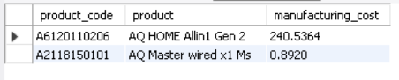**

**6. Generate a report which contains the top 5 customers who received an average high pre_invoice_discount_pct for the fiscal year 2021 and in the Indian market.  
  
Input Code:  
SELECT c.customer_code, c.customer,**

**CONCAT(ROUND(AVG(pre_invoice_discount_pct)*100,2),'%') AS average_discount_percentage**

**FROM dim_customer AS c**

**JOIN fact_pre_invoice_deductions AS pid**

**ON C.CUSTOMER_CODE = pid.customer_code**

**WHERE fiscal_year = '2021' AND market = 'India'**

**GROUP BY customer_code, customer**

**ORDER BY AVG(pre_invoice_discount_pct) DESC**

**LIMIT 5;  
  
Output:  
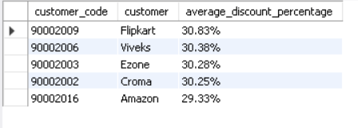**

**7. Get the complete report of the Gross sales amount for the customer “Atliq Exclusive” for each month. This analysis helps to get an idea of low and high-performing months and take strategic decisions.**

**Input Code:  
SELECT**

**MONTH(date) AS month_name,**

**YEAR(date) AS year_,**

**ROUND(SUM(gross_price*sold_quantity)/1000000,2) AS Gross_sales_Amount**

**FROM fact_sales_monthly AS a**

**JOIN fact_gross_price AS b**

**ON a.product_code = b.product_code**

**GROUP BY month_name, year_;  
  
Output:  
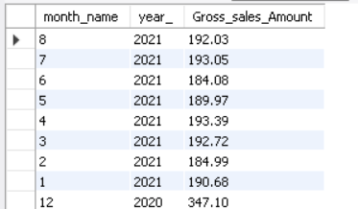**

**8. In which quarter of 2020, got the maximum total_sold_quantity .  
  
Input Code:  
SELECT**

**CASE**

**WHEN MONTH(DATE) IN (9,10,11) THEN 'Q1'**

**WHEN MONTH(DATE) IN (12,1,2) THEN 'Q2'**

**WHEN MONTH(DATE) IN (3,4,5) THEN 'Q3'**

**ELSE 'Q4'**

**END AS quarters,**

**SUM(sold_quantity) AS total_sold_quantity**

**FROM fact_sales_monthly**

**WHERE fiscal_year = '2020'**

**GROUP BY quarters**

**ORDER BY total_sold_quantity DESC;  
  
Output:  
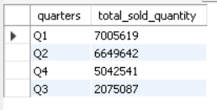**

**9. Which channel helped to bring more gross sales in the fiscal year 2021 and the percentage of contribution?   
  
Input Code:  
WITH cte AS**

**(**

**SELECT channel,**

**ROUND(SUM(gross_price*sold_quantity)/1000000,2) AS gross_sales_mln**

**FROM dim_customer AS c**

**JOIN fact_sales_monthly AS sm**

**ON c.customer_code = sm.customer_code**

**JOIN fact_gross_price AS gp**

**ON sm.product_code = gp.product_code**

**WHERE sm.fiscal_year = '2021'**

**GROUP BY channel**

**)**

**SELECT channel,**

**CONCAT(gross_sales_mln, ' M $') AS gross_sales_mln,**

**CONCAT(ROUND(gross_sales_mln/total*100,2),'%') AS contribution_percentage**

**FROM**

**(**

**(SELECT SUM(gross_sales_mln) AS total FROM cte) AS a,**

**(SELECT * FROM cte) AS b**

**)**

**ORDER BY contribution_percentage DESC;  
  
Output:  
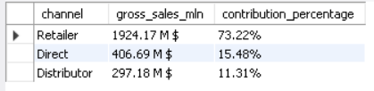**

**10. Get the Top 3 products in each division that have a high total_sold_quantity in the fiscal_year 2021?  
  
Input Code:  
WITH top_products_sold AS**

**(**

**SELECT a.division, a.product_code, a.product,**

**SUM(b.sold_quantity) AS total_sold_quantity**

**FROM dim_product AS a**

**JOIN fact_sales_monthly AS b**

**ON a.product_code = b.product_code**

**WHERE fiscal_year = '2021'**

**GROUP BY a.division, a.product_code, a.product**

**ORDER BY total_sold_quantity DESC**

**),**

**top_sold_by_division AS**

**(**

**SELECT division, product_code, product, total_sold_quantity,**

**DENSE_RANK () OVER (PARTITION BY division ORDER BY total_sold_quantity DESC) AS rank_order**

**FROM top_products_sold**

**)**

**SELECT * FROM top_sold_by_division**

**WHERE rank_order <= 3;  
  
Output:  
